Llandow Ward Community Council Report
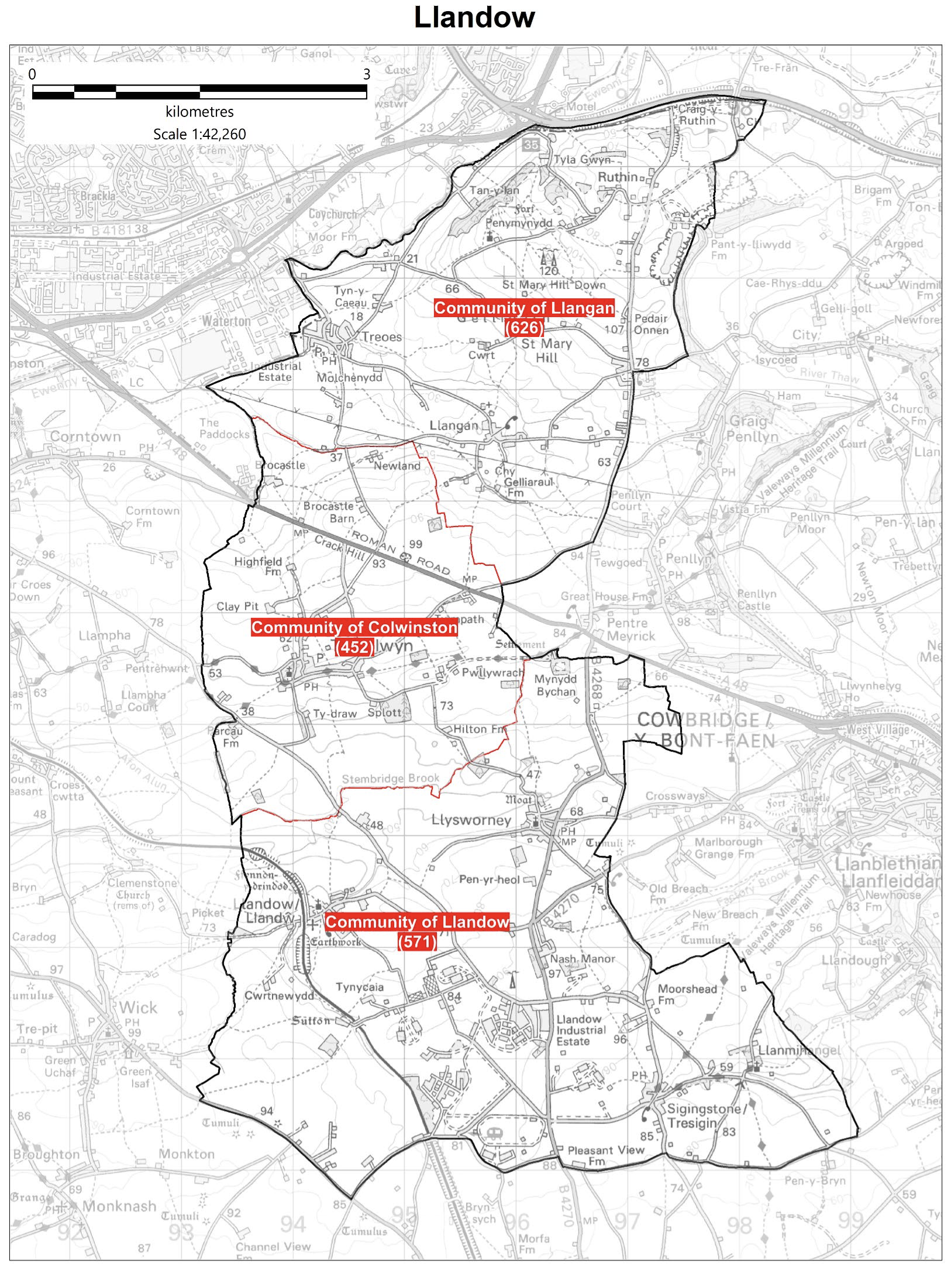

Cllr. Christine Cave email: cacave@valeofglamorgan.gov.uk
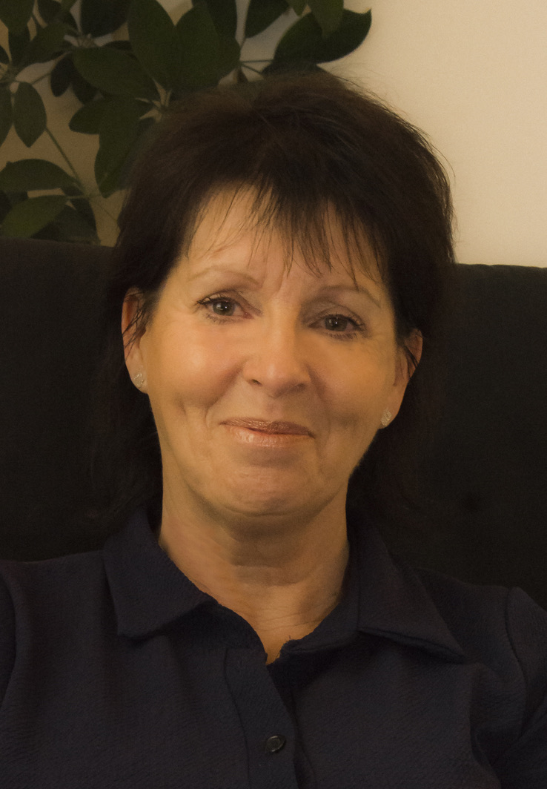
Date: February/March 2023- Report to the Community Councils (CC) in the Llandow Ward: Colwinston; Llandow/, Llysworney, Sigingstone, Sutton and Llangan/Treoes and St Mary Hill.

Vale of Glamorgan Full Council meeting date for 2022/23:-

6th March, 2023
24th April, 2023.

Members of the Cabinet:
Councillor L. Burnett (Executive Leader and Cabinet Member for Performance and Resources) – Labour Party
Councillor B.E. Brooks (Deputy Leader and Cabinet Member for Sustainable Places) – Labour Party
Councillor R.M. Birch (Cabinet Member for Education, Arts and the Welsh Language) – Labour Party
Councillor M.R. Wilson (Cabinet Member for Neighbourhood and Building Services) Labour Party
Councillor M.R. Wilkinson (Cabinet Member for Public Sector Housing and Tenant Engagement) Labour Party
Councillor E. Williams (Cabinet Member for Social Care and Health) Llantwit First Party
Councillor S. Sivagnanam (Cabinet Member for Community Engagement, Equalities and Regulatory Services) Labour Party
Councillor G. John (Cabinet Member for Leisure, Sport and Well-being) Llantwit First Party

Cabinet meeting Minutes of a hybrid meeting held on: 2nd, 16th and 27th 2023 all remote meetings

THURSDAY, 2ND FEBRUARY, 2023 AT 2.00 PM

AGENDA

PART I

1. Apologies for absence.
[View Minute]

2. Minutes of the Meeting held on 19th January, 2023.
[View Minute]

3. To receive declarations of interest.
(Note: Members seeking advice on this item are asked to contact the Monitoring Officer at least 48 hours before the meeting).
[View Minute]

References –
4. Whistleblowing: Staff Survey Results and Annual Report – Governance and Audit Committee, 12th December, 2022.
[View Minute]
5. Project Zero Update Report - Corporate Performance and Resources Scrutiny Committee, 18th January, 2023.
[View Minute]
6. Audit Wales: Vale of Glamorgan Council Assurance and Risk Assessment (ARA) Review 2021/22 and the Auditor General for Wales National Study Report on Public Sector Carbon Readiness for Net Zero by 2030 - Corporate Performance and Resources Scrutiny Committee, 18th January, 2023.
[View Minute]
7. Cost of Living Support for Food, Warm Spaces and Other Means of Support - Corporate Performance and Resources Scrutiny Committee, 18th January, 2023.
[View Minute]
Reports of Meetings –
8. Cardiff Capital Region Regional Cabinet: 28th November, 2022.
[View Minute]
9. Local Access Forum: 29th November, 2022.
[View Minute]
10. Cardiff Bay Advisory Committee: 4th January, 2023.
[View Minute]
Report of the Executive Leader and Cabinet Member for Performance and Resources –
11. Pay Policy 2023/2024.
[View Minute]
Report of the Cabinet Member for Education, Arts and the Welsh Language –
12. Statutory Consultation to Expand Ysgol Iolo Morganwg from 210 places to 420 places from September 2025.
[View Minute]
Report of the Cabinet Member for Public Sector Housing and Tenant Engagement –
13. Housing Revenue Account Business Plan.
[View Minute]
Report of the Cabinet Member for Leisure, Sport and Well-being –
14. Reshaping Services: Single Use Sports Facilities.
[View Minute]

THURSDAY, 16TH FEBRUARY, 2023 AT 2.00 PM

AGENDA

PART I

1. Apologies for absence.
[View Minute]
2. Minutes of the Meeting held on 2nd February, 2023.
[View Minute]
3. To receive declarations of interest.
(Note: Members seeking advice on this item are asked to contact the Monitoring Officer at least 48 hours before the meeting).
[View Minute]
References –
4. Draft Vale of Glamorgan Council Annual Delivery Plan 2023-24 – Corporate Performance and Resources Scrutiny Committee, 15th February 2023.
[View Minute]
5. Chief Officer Appraisal Scheme - Proposed Modifications – Corporate Performance and Resources Scrutiny Committee, 15th February 2023 (View Reference).
[View Minute]
Reports of the Executive Leader and Cabinet Member for Performance and Resources –
6. Council Tax Unoccupied Dwellings: 2024/25.
[View Minute]
7. Timetable of Meetings: May 2023 to May 2024.
[View Minute]
8. Draft Vale of Glamorgan Council Annual Delivery Plan 2023-24.
[View Minute]
9. Cost of Living: The Living Wage and Pay Rates for Grades One and Two Staff.
[View Minute]
Report of the Cabinet Member for Community Engagement, Equalities and Regulatory Services –
10. Annual Equality Monitoring Report 2021-2022.
[View Minute]
Report of the Cabinet Member for Leisure, Sport and Well-being –
11. Penarth Health Hub.
[View Minute]
12. Any items which the Chair has decided are urgent (Part I).
(i) Reference -
Section 6 of the Local Government (Wales) Measure 20211 - Timing of Council Meetings - Democratic Services Committee: 13th February, 2023.
[View Minute]

MONDAY, 27TH FEBRUARY, 2023 AT 2.00 PM
AGENDA
PART I

1. Apologies for absence.

2. Minutes of the Meeting held on 16th February, 2023.

3. To receive declarations of interest.
(Note: Members seeking advice on this item are asked to contact the Monitoring Officer at least 48 hours before the meeting).

Reports of the Executive Leader and Cabinet Member for Performance and Resources –
4. Capital Strategy 2023/24 and Final Capital Programme Proposals 2023/24 to 2027/28 (View Reference from Corporate Performance and Resources Scrutiny Committee: 15th February, 2023)
5. Treasury Management and Investment Strategy 2023/24 and Update 2022/23.
6. Final Budget 2023/24 and MTFP 2023/24 to 2028/29 (View Reference from Corporate Performance and Resources Scrutiny Committee: 15th February, 2023).
7. Financial Management Code Update 2022/23.
8. Corporate Asset Management Plan 2023-2028.
9. People Strategy and Supporting Documents.
10. Procurement Policy and Strategy.
11. Procurement Service – New Service Delivery Arrangements and Delegation Agreement.

Report of the Cabinet Member for Social Care and Health –
12. Recommissioning of Family Support Services in the Vale of Glamorgan.

Report of the Cabinet Member for Community Engagement, Equalities and Regulatory Services–
13. The Vale of Glamorgan Local Development Plan 2011-2026: Supplementary Planning Guidance on Retail and Town Centre Development and Economic Development, Employment Land and Premises – Consultation Feedback, Proposed Changes and Adoption.

14. Any items which the Chair has decided are urgent (Part I).
(i) Reference -
Vale of Glamorgan Council - Proposed Fees and Charges for 2023/2024 - Corporate Performance and Resources Scrutiny Committee: 15th February, 2023.

Current Consultations Vale of Glamorgan Council
Participate Vale
The council want to give everyone the opportunity to get involved and help shape services in the Vale of Glamorgan.
Their public participation platform, Participate Vale, is the best place to find out about our current consultations and share your views.

Visit Participate Vale to have your say and get involved:
Visit Participate Vale
Public Participation Strategy
The Council’s Public Participation Strategy explains how they will encourage and facilitate public participation in the Council's decision making process.
Public Participation Strategy
Review of statues, monuments, street and building names and suggestions for future recognition and commemoration.
The Council is proactively reviewing all statues and commemorations in the Vale of Glamorgan. This work will ensure statues and commemorations on public land, as well as the names of streets and buildings are representative of local people’s values and those of a modern, inclusive Council. If you have seen a commemoration that you think should be reviewed to ensure it is appropriate, please complete our online form. Please ensure you include the location and reason for review.
Recognition and Commemoration

Local Matters
- Rural Road Traffic issues/road safety: identification of local road safety hotspots to inform the way forward – ongoing (this was the main issue discussed with people in Treoes when I visited at the end of February.
- Llandow waste recycling centre – issues raised at full council in December, several emails sent over the last month asking for further information about the relocation of the recycling centre. Engaged with people locally on the matter continues
- Colwinston – Adoption of the Vines - drainage approved and the Vale of Glamorgan should proceed with adoption – an email was sent at the start of January to the officer at the VoG for an update. A further request was sent this week - ongoing
- Colwinston – Llandow – Treoes – Llangan - Sigingston Request for food waste bags delivery made to the Sycamore Tree Colwinston, Star Inn Treoes, Victoria Inn Sigingston, bus stop in Llangan and Village Hall in Llandow
- Colwinston – Twmpath Track Obstruction - ongoing
- Colwinston - Parliamentary Boundary Review – ongoing
- Colwinston – Damaged Light Box, St Michaels Close, reported to the highways team
- Colwinston – several streetlights are broken, some of which have now been repaired but others still remain broken – request for repairs has been made – ongoing
- Colwinston – St David’s Church in Wales school – a meeting with the school was due to be held this month but I have been informed that this will not now take place and we are likely to be invited to visit the school in the next few months
- Colwinston – St David’s Church in Wales – issue reported regarding temporary bollards outside the school – awaiting response
- Cowlinston – possible homelessness issue raised with the VoG homelessness team – ongoing

- Llandow – Fly tipping reported by the cross roads into Llandow Village and also by the lay-by near the farm shop on the Llantwit Road - removed
- Llandow –Nash Junction/Llysworney broken signage raised again with VoG Officer– ongoing.
- Llandow – Llysworney planning application – ongoing
- Llandow – Sigingstone pre planning consultation, matters raised with local AM and others – application will come to the planning committee – new planning application made – ongoing.
- Llandow – Flooding issues raised again with VoG Officer, response provided and being discussed with people locally
- Llangan – Parc Newydd – ongoing
- Llangan – Gypsy Traveller Assessment report – questions raised with VoG Officers
- Llangan – A planning matter raised with VoG officers – resolved

Schedule of meetings for March 2023 - All Meetings commence at 6.00 p.m. and will be held virtually unless otherwise stated.

Council | 6 Mar | Early Retirement/Redundancy (4.00 p.m.) | 23 Mar
Annual Meeting |  | Licensing - Public Protection  (10.00 a.m.) | 7 Mar
Cabinet (2.00 p.m.) | 13 Mar;  27 Mar  2 Mar;  16 Mar;  30 Mar | Licensing - Statutory  (immediately following Public Protection Licensing)
Scrutiny (Corporate Performance and Resources) | 15 Mar | Licensing Sub (10.00 a.m.)
Scrutiny (Environment and Regeneration) | 14 Mar | Planning (4.00 p.m.)  [View Live Stream - 1 March] | 1 Mar;  29 Mar
Scrutiny (Healthy Living and Social Care) (5.00 p.m.) | 7 Mar | Public Rights of Way (10.00 a.m.) | 9 Mar
Scrutiny (Homes and Safe Communities) | 8 Mar | Senior Management Appointment (10.00 a.m.)
Scrutiny (Learning and Culture) | 9 Mar | Standards (10.00 a.m.) | 23 Mar
Appeals |  | Trust (4.00 p.m.)
Goverance and Audit |  | Vale of Glamorgan Local Access Forum (5.30 p.m.)
Community Liaison | 23 Mar | Voluntary Sector Joint Liaison
Democratic Services (4.00 p.m.) |  | Welsh Church Act Estate (4.00 p.m.)
Investigating |  | Shared Regulatory Services Joint Committee (10.00 a.m.) | 21 Mar

